Hello and welcome to West Street Potters.
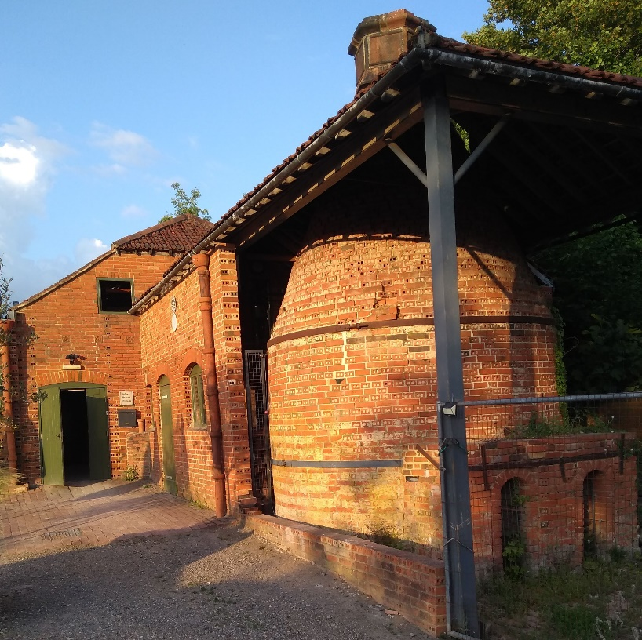

West Street Potters Aim
To develop students’ creative abilities through the acquisition of practical skills and an appreciation of the broader aspects of ceramics while nurturing a creative community.

Key Names

Directors: Christine Banat, Steve Cook, Lucinda Davis, Jayne Webley, Natty Yannaghas

Tutors: Karen Bardell, Christine Bull, Nikki Hoffman Jane Jones, Myra McDonnell, Kathy Mason, Julia Quigley

Workshop Managers: Scarlett Wilson & Natty Yannaghas

Technicians: Belinda Bassom, Libby Cooper, David Powici, Scarlett Wilson, Natty Yannaghas

Pottery Administration/ Membership/ Events: Elizabeth Yorke – info@weststreetpotters.com

Website: https://www.weststreetpotters.co.uk/

Workshop procedures

What to bring
- Dress for mess, members should wear old clothes and bring along an apron, old towel and notebook.

Tools
  - Members will need to buy a set of pottery tools.
  - A starter set of tools can be bought at Pullingers in Farnham or online (Amazon, Clayman, Blue Matchbox)
  - You can also buy a basic set from WSP at your first class. Please contact Elizabeth on info@weststreetpotters.co.uk if you would like one. We also stock a small amount of individual tools. These are listed on the Zettle. If you would like to purchase one, please let your tutor know at your class.
  - If you are joining a sculpture class, you will need to bring a board with you to put your sculpture on. Recommended size is 40x40xm. We stock a small amount of sculpture tools. If you would like advice on what to buy, it is worth waiting until after your first class so that your tutor can guide you.

Clay
- Clay is available for purchase in the pottery.
- Your tutor has a key and access to the clay cupboard.
- Please pay for your clay via the Zettle as soon as you have collected it.
- A standard bag of stoneware clay is £16.50.
- We also have bags of reclaimed clay for £5.
- In order to prevent expensive damage to our kilns, please do not bring your own clay unless you have agreed with the tutor and carried out a firing test.
- All bags of clay should be taken home as we do not have storage space on site

Moulds
- Moulds must not be removed from the pottery

Please do not touch or move any work that does not belong to you. Work is fragile. If you think something needs to be moved, please ask your tutor/technician.

Damp cupboard
- The damp cupboards are used to keep your work damp if you need to continue work at a later date.
- The damp cupboards are found in the lower workshop. Ask your tutor to identify which cupboard to use for your class.
- Please label your work so that it can be identified.

Drying shelves
- Each class has been allocated shelf space in the upstairs workshop.
- Please ensure that you put your work on the correct shelf – if you are unsure check with your tutor.
- Do not move your work downstairs until it is completely dry, as it cannot be bisque fired until such time – your tutor will be able to advise you when it is ready to move downstairs for firing.

Bisque firing
    - Members should ensure that their work has their class mark and initials on it. Small items can be put in a labelled dish. Your tutor will be able to tell you what your class mark is.
    - Each piece of work for firing needs to be prepaid and have a Zettle receipt.
    - There are laminated instructions on how to use the Zettle next to it.
    - Any work without a receipt will not be fired.
    - If you are unsure, please check with your tutor/technician.

Glazes and glaze firing
    - There are various glazes available on the ground floor in the glazing workshop.
    - Please do not use your own glazes unless you have checked with your tutor/technician and have done a test piece. It can damage our kiln shelves which are expensive to replace.
    - Each piece of work for firing needs to be prepaid and have a Zettle receipt.
    - Any work without a receipt will not be fired.
- Please note that there are different shelves for different temperature firings.
- If you are unsure, please check with your tutor/technician.

Firing charges
As members become more skilled and potentially produce unusually large quantities of work, this can cause delays for other members. If this is the case, after discussion with the member, WSP and their tutor may decide to limit the quantity of work that may be fired. There is, however, the opportunity to hire kilns, over the holiday periods. With technical support, this will be priced accordingly. This needs to be pre-booked. Requests should be made via your tutor and the Workshop Technicians.

Please take your work home once it has been fired and glazed (whether you like how it has turned out or not and broken or not!) – It is a very busy pottery, and the shelves need to be kept clear on a regular basis to make room for new work, prevent damage and to help our technicians.

Food and drink
    - No food or drink is allowed in the workshop. Covered drinks and bottled water are permitted.

Cleaning
  - You are responsible for keeping the workshop clean and tidy, so that it is a pleasant place for everyone to create.
  - Wet mop any floor spillages that you have made (particularly important if you use a wheel). Brooms are not to be used in the workshop as they create airborne dust.
  - Clean/wash down any pottery equipment used (wheels, moulds, rolling pins, paintbrushes, sponges, tabletop etc) and leave the work area ready for the next student.
  - Please put chairs on tables and stools on wheels at the end of your session – This will help our cleaners greatly.
  - Use the basin in the sink for preliminary cleaning, to minimise the use of water and clay going down the sink and overfilling the clay trap.
  - At the end of each term, all work must be removed from the workshop to allow for a deep clean and any maintenance.

Social Media
- Most classes have a What’s App Group to keep in touch, we would encourage this as it is a useful tool.
- We love to see what our members are up to so, please do share photos of your work with Pottery Administrator for the WSP blog and website info@weststreetpotters.com .

Health and Safety

Medical conditions
- It is important that all members inform WSP of any physical or mental conditions that tutors should be aware of. This information is treated in the strictest confidence but could potentially avoid incidents due to conditions such as diabetes, epilepsy, cancer or allergy. Tutors will be informed of any medical conditions.
- In order to comply with fire safety regulations, if you have any disability, condition or illness which means you would require help during an emergency evacuation, your Tutor must fill in a Personal Emergency Evacuation Plan (PEEP). This information is treated in the strictest confidence but helps us ensure that we have the right support in place in case of emergency evacuation.
- Please read and sign the Health and Safety in the workshop and Health and Safety in the Glazing Area guidelines

Public Liability Insurance
- WSP Public Liability Insurance Certificate is displayed on the noticeboard.

First aid box, eye wash and Accident book

Located upstairs by the back door in the upper workshop & in the glaze room.

All accidents should be reported in the Accident Book.

Face Masks
  - Dust is our greatest enemy!
  - Masks are available and are to be used during dust producing activities such as glaze preparation. These are chargeable alongside firing charges and cost £1
  - Protective gloves are also available.

Safe use of equipment
- All members should know how to operate equipment safely. If unsure, please ask your tutor/technician before operating any unfamiliar equipment.
- All equipment should be returned in a clean condition to the correct place.
- A mask should be worn when using the spray booth.

Health and safety in the glaze area
- Wear apron
- Wear gloves if you have sensitive skin
- Clean spills with wet sponge or floor mop
- Large spills, inform Tutor
- Ingredients of glazes can be toxic irritants, so handle with care
- Dry mixing of powders is not allowed unless all in the area are masked correctly
- Many ingredients can be toxic if inhaled / ingested in quantity or through skin contact. Ask your Tutor for a list if you are worried.
- Most important is cleaning of your hands, apron and area
- Residual dust is the main hazard!

Health and safety in the workshop
- Dry fettling (i.e. sanding is NOT allowed in the workshop unless all are wearing a dust mask and over a water bowl or OUTSIDE away from the public to reduce dust
- Tables/wheels and tools to be thoroughly wet wiped down after use
- Cleaning of floor with wet mope and or HEPA filter vacuum
- Wear and apron and wash after use to remove clay
- Dust is our main hazard. Accumulations of fine silica dust in the lungs cause asthma and silicosis eventually

In case of fire
  - The Assembly Point is in the corner of the car park opposite the Farnham Pottery. Fire extinguishers are available by the stairs in the upper workshop.
  - In case of fire, the lift must not be used.
  - West Street Potters fire wardens are:
    - Christine Banat (Director, Member Wednesday Morning)
    - Karen Bardell (Tutor Wednesday and Thursday Evening)
    - Belinda Bassom (Technician, Member Friday Morning)
    - Christine Bull (Tutor Tuesday Evening)
    - Steve Cook (Director, Member Monday Evening)
    - Libby Cooper (Technician)
    - Jane Henderson (Member Tuesday Evening)
    - Nikki Hoffman (Director, Tutor Wednesday Morning, Wednesday Afternoon, Member Monday Morning)
    - Jane Jones (Tutor Monday Morning)
    - Kathy Mason (Tutor Thursday Morning, Friday Morning and Friday Afternoon)
    - Myra McDonnell (Tutor Monday Afternoon and Monday Evening)
    - David Powici (Technician)
    - Julia Quigley (Tutor, Tuesday Morning and Tuesday Afternoon)
    - Jayne Webley (Director, Member Monday Morning and Thursday Morning)
    - Scarlet Wilson (Technician, Member Wednesday Evening)
    - Natty Yannaghas (Technician and Member Friday Morning)
    - Elizabeth Yorke (Pottery Administrator, Member Friday Morning)

  - Emergency First Aiders
    - Karen Bardell (Tutor Wednesday and Thursday Evening)
    - Belinda Basson (Technician, Member Friday Morning)
    - Christine Bull (Tutor Tuesday Evening)
    - Libby Cooper (Technician)
    - Jane Henderson (Member Tuesday Evening)
    - Nikki Hoffman (Director, Tutor Wednesday Morning, Wednesday Afternoon, Member Monday Morning)
    - Jane Jones (Tutor Monday Morning)
    - Kathy Mason (Tutor Thursday Morning, Friday Morning and Friday Afternoon)
    - Myra McDonnell (Tutor Monday Afternoon and Monday Evening)
    - Julia Quigley (Tutor, Tuesday Morning and Tuesday Afternoon)
    - Scarlett Wilson (Technician, Member Wednesday Evening)
    - Natty Yannaghas (Technician and Member Friday Morning)

